Your Title should be here Title Title Title Title Title Title Title Title Title Title Title Title Title Title Title
First name Last name¹, First name Last name², First name Last name^{2,*}
¹ Affiliation 1
² Affiliation 2
* Corresponding author: Author Name, Email
Abstract. All articles must contain an abstract. The abstract text should be formatted using 10 point Times or Times New Roman and indented 25 mm from the left margin. Leave 10 mm space after the abstract before you begin the main text of your article, starting on the same page as the abstract. The abstract should give readers concise information about the content of the article and indicate the main results obtained and conclusions drawn. The abstract is not part of the text and should be complete in itself; no table numbers, figure numbers, references or displayed mathematical expressions should be included. It should be suitable for direct inclusion in abstracting services and should not normally exceed 200 words in a single paragraph. Since contemporary information-retrieval systems rely heavily on the content of titles and abstracts to identify relevant articles in literature searches, great care should be taken in constructing both.
- Introduction
In conjunction with the 3rd ICWSDGs 2026 theme, papers of relevant topics within the conference theme are invited for oral/poster presentations. Authors are requested to submit an extended abstract not exceeding three (3) pages in English.
An introduction should announce your topic, provide context and a rationale for your work, before stating your research questions and hypothesis. Well-written introductions set the tone for the paper, catch the reader's interest, and communicate the hypothesis or thesis statement.
- What is the problem or issue being addressed?
- What is the method or process?
- What was the resultant data?
- What did you find from the analysis?
- What are your conclusions, their scope in which they may be applied and what would you suggest for future work?
- What references have you checked so that you are not re-inventing the wheel?
It is recognized that you may not be completely done with your work, yet. But you must have the reasonable expectation of being completely done when you write the full paper. You must also be prepared to address issues raised by the reviewers in the final paper. The manuscript should be prepared on an A4-sized paper with single spacing using size 11 Times New Roman font. All illustrations must be prepared inside of the main text.

These guidelines, written in the style of a submission to J. Phys.: Conf. Ser., show the best layout for your paper using Microsoft Word. If you don’t wish to use the Word template provided, please use the following page setup measurements.

Margin | A4 ONLY – DO NOT USE US LETTER
Top | 4.0 cm
Bottom | 2.7 cm
Left | 2.5 cm
Right | 2.5 cm
Gutter | 0 cm
Header | 0 cm
Footer | 0 cm

It is vital that you do not add any headers, footers or page numbers to your paper; these will be added during the production process at IOP Publishing (this is why the Header and Footer margins are set to 0 cm in table 1).
- The Content of the Extended Abstract
All materials and methods that have been used in the work must be stated clearly and subtitles should be used when necessary.

2.1. Subtitle
First degree titles (2.) should be written left aligned, all caps and bold. Second and 3rd degree subtitles (2.1, 2.1.1) should be written left aligned, italic. A blank line should be placed between the paragraphs and there should not be any paragraph indentation. Lorem ipsum dolor sit amet, consectetur adipiscing elit. Integer nec odio. Praesent libero. Sed cursus ante dapibus diam. Sed nisi. Nulla quis sem at nibh elementum imperdiet. Duis sagittis ipsum. Praesent mauris. Fusce nec tellus sed augue semper porta. Mauris massa. Vestibulum lacinia arcu eget nulla. Class aptent taciti sociosqu ad litora torquent per conubia nostra, per inceptos himenaeos. Curabitur sodales ligula in libero. Sed dignissim lacinia nunc. Curabitur tortor. Pellentesque nibh. Aenean quam. In scelerisque sem at dolor. Maecenas mattis. Sed convallis tristique sem. Proin ut ligula vel nunc egestas porttitor.

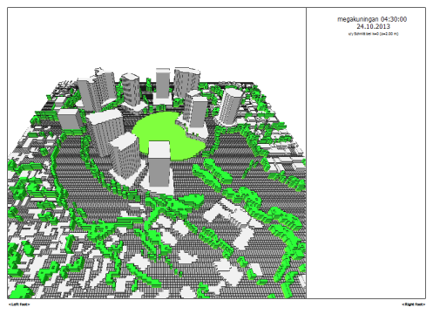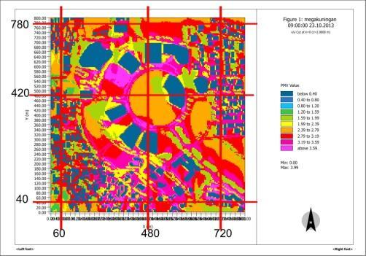
Figure 1. (a) Figure Header; (b) Figure Header

  - 2.2 Discussion
The purpose of the discussion is to interpret and describe the significance of your findings in light of what was already known about the research problem being investigated, and to explain any new understanding or fresh insights about the problem after you've taken the findings into consideration. It is not more than one paragraph.

Table 1. Formatting sections, subsections and subsubsections.
 | Unit | Low | High
Final temperatures | °C | 25 | 29
Heat Transfer | °C/sc | 27 | 31
Condensing Temperature | °C | 0 | 10
Reference: author surname and publication date
- Congclusion
An extended abstract is a research paper whose ideas and significance can be understood in less than an hour. "Some things that can be omitted in an extended abstract are, for example,future work, very specific details of tests, institutional information and ramifications that are not relevant to the key ideas of the abstract (William Pugh W. Advice to authors of extended abstracts.)
An extended abstract must not exceed 3 pages long (with figures, table, and explanations) and 1250 words long. An extended abstract is not simply a long abstract. The extended abstract should contain references, comparisons to related works and other details expected in a scientific paper but not in an abstract.

References
Examples taken from published papers:

[1] Sze S M 1969 Physics of Semiconductor Devices (New York: Wiley–Interscience)
[2] Dorman L I 1975 Variations of Galactic Cosmic Rays (Moscow: Moscow State University Press) p 103
[3] Caplar R and Kulisic P 1973 Proc. Int. Conf. on Nuclear Physics (Munich) vol 1 (Amsterdam:
North-Holland/American Elsevier) p 517
[4] Szytula A and Leciejewicz J 1989 Handbook on the Physics and Chemistry of Rare Earths vol 12, ed K A Gschneidner Jr and L Erwin (Amsterdam: Elsevier) p 133
[5] Kuhn T 1998 Density matrix theory of coherent ultrafast dynamics Theory of Transport Properties of Semiconductor Nanostructures (Electronic Materials vol 4) ed E Schöll (London: Chapman and Hall) chapter 6 pp 173–214

Acknowledgments
Authors wishing to acknowledge assistance or encouragement from colleagues, special work by technical staff or financial support from organizations should do so in an unnumbered Acknowledgments section immediately following the last numbered section of the paper.

